# Market Research

## Flavored Water

* Market grew 50% annually from 2001-20041
* 270 billion dollars in 2005 for beverages1
  + 25% (66 billion) spent on carbonated beverages1
* “New Age” Beverages spiked due to studies of proper hydration and over consumption of sugar (early 2000’s)1
  + Water spiked in popularity, with flavored water becoming an alternative1
* Flavored water suspected to out-sale carbonated beverages (2010 and beyond; data not found)1
  + Popular Brands like Vitamin Water, and MiO still on the rise5
  + Trends for MiO, Flavor Enhanced Water, Vitamin Water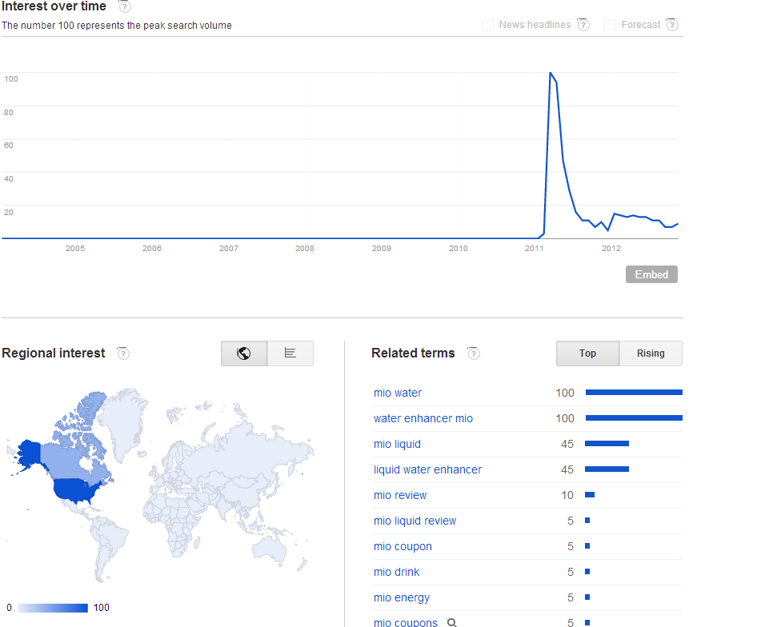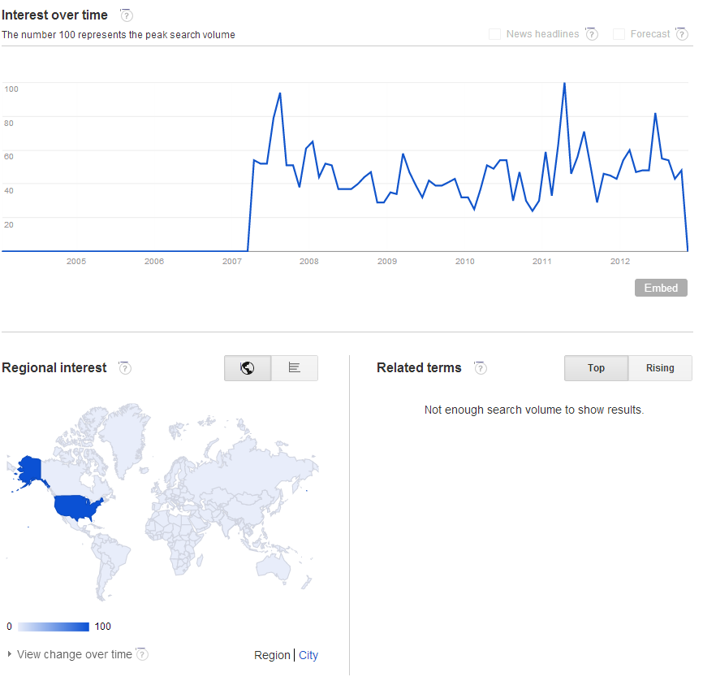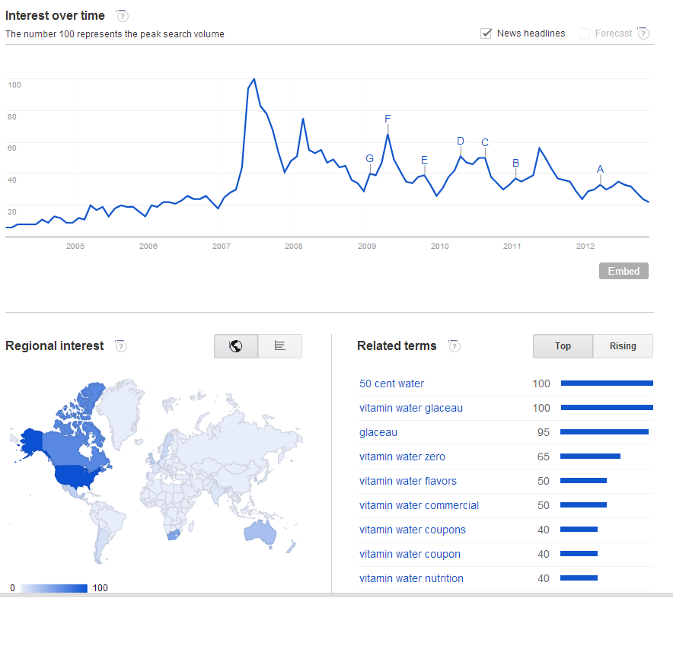

## Portable Water Bottle Filter

* Slightly new market
  + Bobble released in 2010, already in all 50 states, three dozen countries2
    - Currently in more than 35000 stores
    - Millions sold worldwide
  + Many brands with different designs
  + Increasing popularity due to features2
    - Some filters work on –any- water
    - Portable is convenient
  + People (Americans) more conscious of even tap water smell/taste3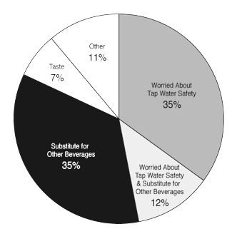
  + Trends for Flavored Water Vs. Portable Water Bottle Filters

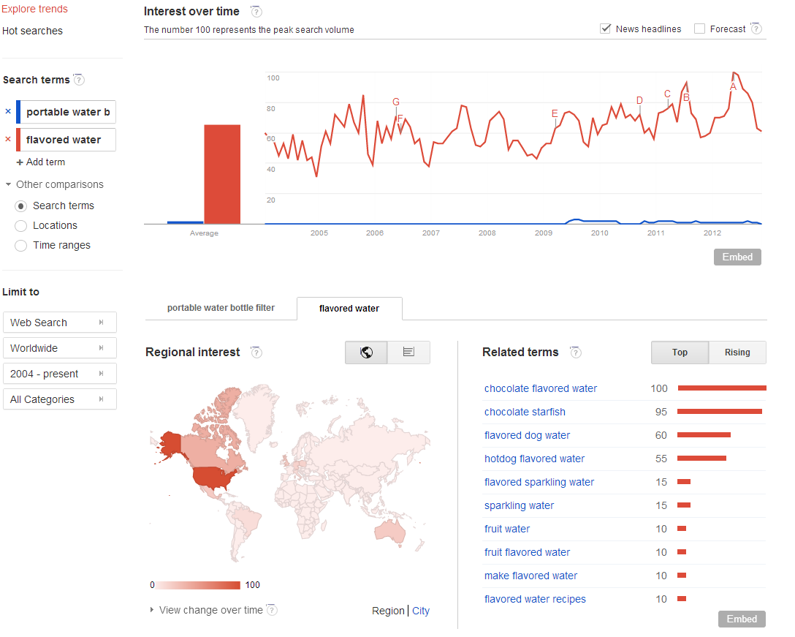

<http://www.wyattresearch.com/article/sector_watch_flavored_water/73641>

<http://www.waterbobble.com/our-story>2

<http://www.waterindustry.org/frame-1.htm>3

<http://coffeetea.about.com/od/water/tp/waterbottles.htm>4

<http://kathrynvercillo.hubpages.com/hub/Top-10-Brands-of-Flavored-Water>5